Threat Prioritization Plan

# Revision

Version 9

5/26/22 11:56 AM

# SME

Charles Wilson

# Abstract

This document details the process to be used to formally develop threat models and process the results from that activity into actionable issues able to be dispositioned by development teams.

# Group / Owner

Security / Systems Requirements Planner

# Motivation

This document is motivated by the need to have formal processes in place regarding discovery and disposition of security-related threats to allow for certification of compliance to standards such as **ISO 21434** and **ISO 26262**.

# License

This work was created by **Motional** and is licensed under the **Creative Commons Attribution-Share Alike (CC BY-SA-4.0)** License.

[**https://creativecommons.org/licenses/by/4.0/legalcode**](https://creativecommons.org/licenses/by/4.0/legalcode)

# Overview

The following diagram illustrates the process to be used:

## 

**Note:** The methodology laid out above follows that described in guidance from both NIST SP 800-30 **[9]**.

# Process

## Threat Candidate Ranking

|  |  |
| --- | --- |
| **Inputs** | Triaged threat candidates |
| **Outputs** | Ranked threat candidates |
| **Participants** | Security SME |

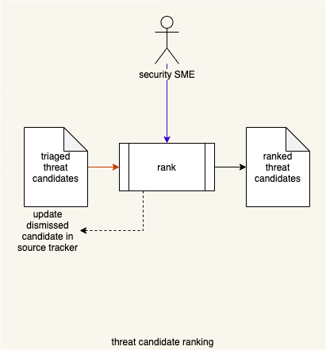

The **triaged threat candidates** are ranked in order to establish their relative exploitability. This should be done using a standard ranking methodology such as the Common Vulnerability Scoring System (**CVSS**) **[5]**.

The ranking should consider aspects such as:

* Mechanism
* Locality
* Maturity
* Scope
* Required privileges

The ranking system may lend itself to coarse ranking (by range).

Once ranked, a threshold may be applied to reduce the number of threat candidates needing to be considered in the risk step. If a threshold is applied, the dismissed candidates must be documented in the candidate’s source tracker.

**Note:** The **triaged threat candidates** may be sourced from several activities, including:

* Threat modeling **[2]**
* Incident response **[3]**
* Attack surface analysis **[4]**

## Ranked Threat Candidate Risking

|  |  |
| --- | --- |
| **Inputs** | Ranked threat candidates |
| **Outputs** | Risked threat candidates  Ranked / risked threat report |
| **Participants** | Risk SME |

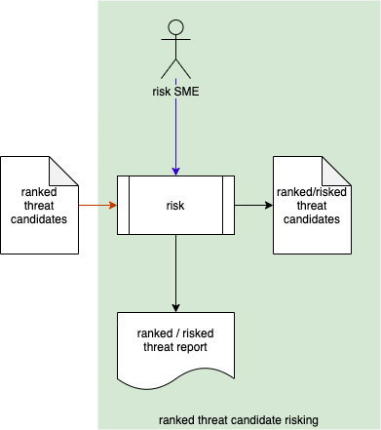

The ranked threat candidates meeting the threshold of consideration are reviewed by the risk SME to determine their severity of harm. A **ranked / risked threat report** is generated.

## 

## Threat Candidate Slicing

|  |  |
| --- | --- |
| **Inputs** | Risked threat candidates |
| **Outputs** | Uncontrolled threats  Threat report |
| **Participants** | Security SME |

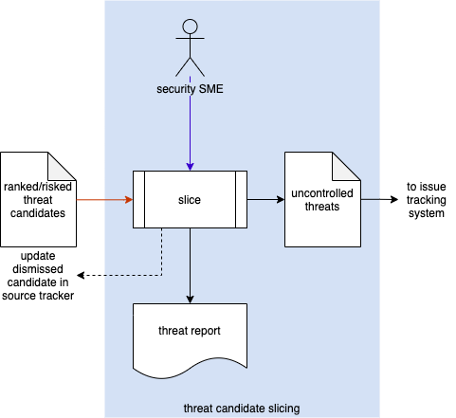

The threat candidates which have been both ranked and risked are sliced (bisected) to determine which ones are considered to have uncontrolled risk. These are designated as uncontrolled threats and forwarded to the **issue tracking system**. If an issue is determined to be controlled, an **update dismissed candidate** **notification** is sent to the **source tracker** to document this. A **threat report** is generated.

**Note:** It is the responsibility of the standard issue management processes to dispose of uncontrolled issues applying the standard treatments (avoid, reduce, share, retain). This includes documenting the risk aspects of the issue and the reason for the disposition.

The following diagram illustrates issue slicing.

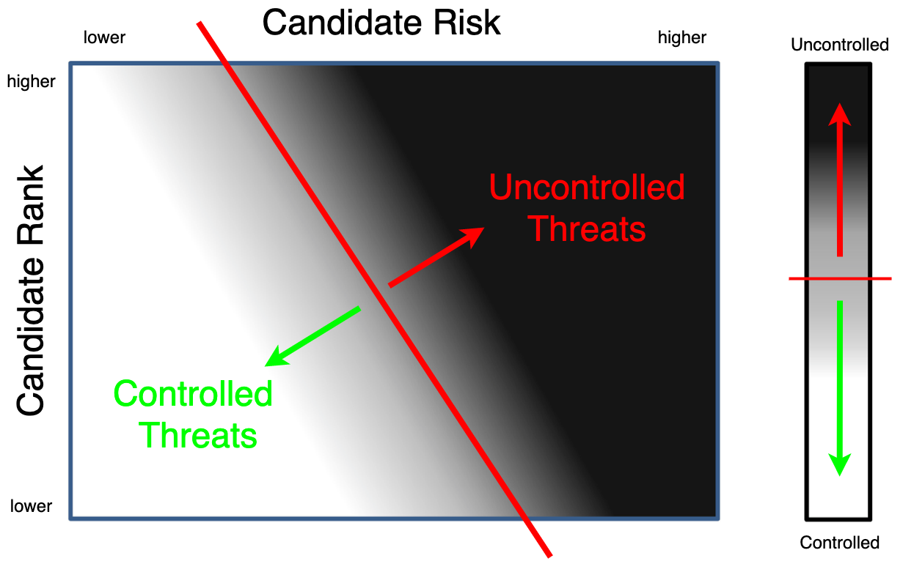

**Note:** Adapted from **Postmarket Management of Cybersecurity in Medical Devices [10]**.

Here we are showing both the values from ranking and risk as continuous. The level of risk control is also shown as continuous from white (completely controlled) to black (completely uncontrolled). In practice, risk is quantized (for example: negligible, minor, major, catastrophic). Rank is also not truly continuous as with CVSS we see 101 discrete ranks produced ([0.0, 10.0] in 0.1 steps). Finally, our desire is to bisect the space by choosing a minimum level of acceptable risk. This yields a line through the exploitability-severity space above which threats are deemed to be “in need of mitigation” (indicated with the red line and arrow).

**Note:** Additional information regarding the mapping of various ranking and risking methodologies into the notation specified by **ISO 21434** can be found in the **Ranked / Risked Threat Report [7].**

**Note:** The issue of reporting when multiple risk dimensions are considered, as by **ISO 21434**, is addressed in the **Threat Report [8].**

If a threat candidate is determined to be controlled, it is dismissed and must be documented in the candidate’s source tracker. **Uncontrolled threats** will be entered into the defect tracking system for disposition by development.

**Note:** The bisection line is determined by the organization’s risk acceptance level.

# References

1. **Document Management Standard**[**https://en.wikipedia.org/wiki/Document_management_system**](https://en.wikipedia.org/wiki/Document_management_system)
2. **Threat Modeling Report** (AVCDL secondary document)
3. **Incident Response Plan** (AVCDL secondary document)
4. **Attack Surface Analysis Report** (AVCDL secondary document)
5. **Common Vulnerability Scoring System**[**https://www.first.org/cvss/**](https://www.first.org/cvss/)
6. **NIST SP 800-39 - Managing Information Security Risk - *Organization, Mission, and Information System View***[**https://nvlpubs.nist.gov/nistpubs/Legacy/SP/nistspecialpublication800-39.pdf**](https://nvlpubs.nist.gov/nistpubs/Legacy/SP/nistspecialpublication800-39.pdf)
7. **Ranked / Risked Threat Report** (AVCDL secondary document)
8. **Threat Report** (AVCDL secondary document)
9. **NIST SP 800-30 r1 - Guide for Conducting Risk Assessments**[**https://nvlpubs.nist.gov/nistpubs/Legacy/SP/nistspecialpublication800-30r1.pdf**](https://nvlpubs.nist.gov/nistpubs/Legacy/SP/nistspecialpublication800-30r1.pdf)
10. **Postmarket Management of Cybersecurity in Medical Devices**[**https://www.fda.gov/regulatory-information/search-fda-guidance-documents/postmarket-management-cybersecurity-medical-devices**](https://www.fda.gov/regulatory-information/search-fda-guidance-documents/postmarket-management-cybersecurity-medical-devices)